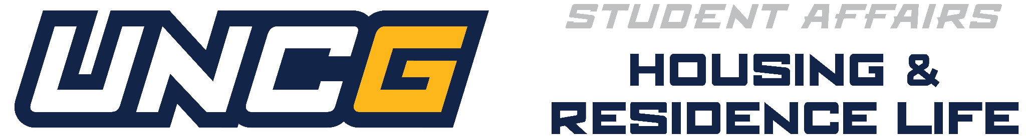

Resident Advisor 2027-2028 Role
2027-2028 New Resident Advisor Process Timeline & Checklist
***Please Note: There is a different process for Returning/Previous UNCG RAs***
Housing and Residence Life (HRL) is excited that you’re interested in joining our team for the 2027–2028 academic year! At the University of North Carolina at Greensboro, we take pride in offering meaningful leadership opportunities that help students grow, serve, and embody the true Spartan spirit. We hope you find the Resident Advisor role to be a place where you can lead, support your peers, and make a lasting impact on our residential communities.
Below you’ll find important information about the New Resident Advisor process, timeline, and checklist to guide you through the selection experience. We encourage you to review everything carefully and reach out with any questions about the position or expectations.
A new RA is considered to be someone who is interested in the RA role and has not served in the RA role at UNCG. For the full position description visit our HRL Employment website.
How to Apply | Round 1:
- Attend An Info Session: All new RA candidates must attend one (1) information session to learn about the role, expectations, and the RA experience at UNCG. These sessions give you the chance to connect with members of the Student Staff Recruitment & Selection Committee and explore whether the RA position is the right fit for you as a future Spartan leader. Attendance will be taken at each session.
  - Sessions will take place from October to December 2026 with dates posted in September 2026! Please check back then!

- Complete the Online Application: The application includes several components designed to help us learn more about your leadership potential, your interest in community building, and your commitment to the values of Housing & Residence Life. You’ll be asked to provide background information, reflect on your experiences, and respond to questions that highlight your interest in the role.
  - The application will open on October 2, 2026 and be visible on the HRL Employment website.

- Big Interview : All new RA candidates in the process will complete the BigInterview virtual experience from an environment of their choosing, at a time of their choosing. This virtual interview will present HRL interview questions with candidates recording their own responses.
  - Instructions on How to Complete & Submit your Big Interview will be visible on the HRL Employment Website once the application opens in October 2026.
All application materials must be submitted by December 20, 2026 for consideration of the Resident Advisor Role.
A complete application includes Big Interview Video, Attendance at Info Session, & Submitted Online Application.
Round 2:
After all candidate materials have been submitted, applicants who advance in the process will receive communication with details about the Round 2 Interview Weekend.
- Invitation to Interview Weekend: RA candidates will be invited to an in-person selection experience in February 2027.
  - Interview Selection Weekend : RA Interview Weekend is an invite-only welcoming, and interactive experience designed to help candidates show who they are, how they think, and what strengths they would bring to the Residence Life team. Across a series of activities including a traditional interview, a problem‑solving exercise, and an event‑planning activity. Candidates engage with staff, reflect on their values, demonstrate their leadership style, and explore the realities of the RA role. This portion of the candidate application focuses on authenticity, growth, and connection, giving students space to express themselves while learning more about Housing & Residence Life at UNCG.

Process Details:
• New RA Notification (HRL): All new RA candidates will receive their offer/decision letters in late March 2027.
Failure to complete any part of the application or selection process requirements will remove you as a candidate for consideration.
Questions about this process? Email raselect@uncg.edu

