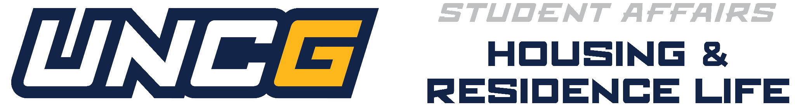

Returning Resident Advisor 2027-2028 Role
2027-2028 Returning Resident Advisor Process Timeline & Checklist
***Please Note: There is a different process for New UNCG RAs***
The Office of Housing and Residence Life (HRL) is excited that you have a continued interest in serving with us during the 2027–2028 academic year at the University of North Carolina at Greensboro. As a Spartan, you have access to many meaningful student leadership opportunities that allow you to grow, lead, and make a lasting impact on our residential communities. We want to ensure you have all the information you need as you explore your options and consider returning to the Resident Advisor role for another year.Below you will find important details about the Returning Resident Advisor (RRA) process, including the timeline and checklist to guide you through the selection experience. We encourage you to review everything thoroughly and reach out if you have any specific questions. We look forward to connecting with you throughout this process and appreciate your continued commitment to supporting the Spartan residential experience.
A Returning Resident Advisor (RRA) is any student who has served in the RA role within Housing and Residence Life for one or more semesters by August 2027 at UNCG. For the full position description, please visit our HRL Employment website.
How to Apply:
- Attend Returner Info Session: All Returning RA (RRA) candidates are required to attend the Returning RA Information Session to learn more about the expectations, updates, and opportunities involved in returning to the RA role for the 2027–2028 academic year. These sessions provide space to reconnect with the HRL Student Staff Recruitment & Selection Committee, gain clarity about the RRA application process, and explore what it means to continue serving as a leader within our residential communities.
  - Sessions will take place near/during the October Continuing Development. RAs who are unable to attend must connect with their supervisor to obtain missed information.

- Complete the Online Application: The application includes several components designed to help us learn more about your leadership potential, your interest in community building, and your re-commitment to the values of Housing & Residence Life. You’ll be asked to provide background information, reflect on your experiences, and respond to questions that highlight your interest in the role. Returning RAs will also be asked to provide insight on why they desire to return to the role and how they can aim to support new RAs as a returner.
  - The application will open on November 1, 2026 and close December 1, 2026
  - Application Materials and Information will be provided via email.

- 10-Minute Presentation : As part of the Returning Resident Advisor (RRA) selection process, applicants will record a 10‑minute presentation in which they respond to prompts about their previous RA experience and reflect on what they envision for another year in the role. This presentation should be completed independently and submitted within the designated timeframe.
  - A step‑by‑step guide on how to record your presentation and prompts regarding what to include will be provided during the Returning RA Info Session.
Not Returning:
- Not Returning for Spring 2027 : If you are not planning to return next semester whether due to resignation, studying abroad, graduation, or another transition, you are required to complete the designated intent form. This submission will serve as your official letter of resignation for Housing and Residence Life. If you indicate that you will not be returning, you must be fully vacated from your assigned space by 5:00 PM on Monday, December 14th.
- Not Returning for 2027-2028 Academic Year: If you are not returning for the 2027–2028 academic year, you must submit an official resignation letter to your Coordinator for Residence Life (CRL). Your letter should include the date you intend to conclude your employment. If you are completing the full 2026–2027 RA appointment, please list May 31, 2027 as your official resignation date.

Process Details:
- Returner Application Notice: RA performance, conduct, and evaluations will be reviewed and taken into consideration as part of the Returner RA application.
- Returner RA Notification (HRL): All returning RA candidates will receive their offer/decision letters in late February 2027.
Failure to complete any part of the application or selection process requirements will remove you as a candidate for consideration.
Questions about this process? Email raselect@uncg.edu

